4730 Colby Avenue  Everett  WA  98203  Phone: (425) 385-4023  Fax: (425) 385-4022

April 12, 2011

Dear Representative Hope:

This letter is written on behalf of the nearly 2,000 Trust members of the Everett School Employees Benefit Trust. We have been a VEBA Trust for over 25 years and provide for local management of our health care benefits along with other related benefits such as: disability, supplemental life insurance, long-term care, employee assistance and wellness programs.

We ask that you do not support SB 5612. We urge you to continue allowing school districts the right to choose at the local level the means by which health care coverage is provided.

Our members have input into the programs we offer and continue to be positively affected by these programs. The two attachments to this letter contain a summary of our Trust’s history and a description of the Trusts’ employee Wellness program. As a result of our Wellness program, a large number of our employees understand the direct correlation between their own and their colleagues’ personal health conditions and the ability to control health care costs. The State’s management of the health care program will reduce the personal connection our employees have with that program and the impact that they can personally make on containing costs. For our employees we believe that this will be a step backward in health care management and direction. What will be their incentive to engage in healthy life style choices individually and collectively?

We urge you to vote to continue allowing school districts the right to choose at the local level the means by which health care coverage is provided.

Sincerely,
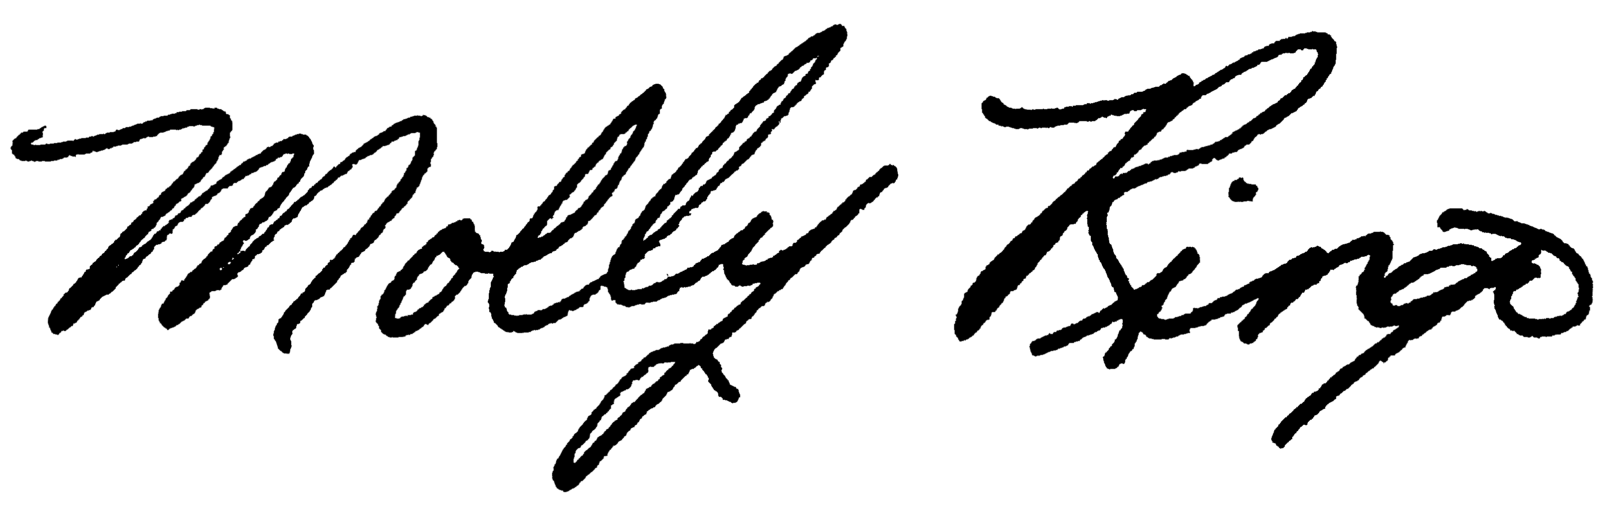
Everett School Employee Benefit Trustees

Attachments

